Latin America Environmental Problems Graphic Organizer

Mexico City Air Pollution

Mexico City is one of the world’s worst areas of air pollution. Mexico City is crowded. Over 19 million people live in Mexico City. In this city are thousands of factories and over 3 million cars. The factories send pollution such as lead, sulfur dioxide, and carbon monoxide into the air. Many of the cars are older models. These older cars produce even more pollution than typical new cars

Geography plays a role in the problems the city faces. The city is built in a bowl-shaped crater of an extinct volcano. The high elevation means that the air is thin, and exhaust from cars and factories get trapped in the valley. The intense sunlight helps to push smog even higher. **Smog**  is a combination of smoke and thick fog

The government of Mexico is working on solutions to this problem. First drivers must leave their cars at home one day per week. Citizens are encourage to ride buses, trains or carpool to work. Cars are inspected more often. Those with very bad exhaust problems must be repaired. On days of the highest pollution levels, certain factories may be closed.

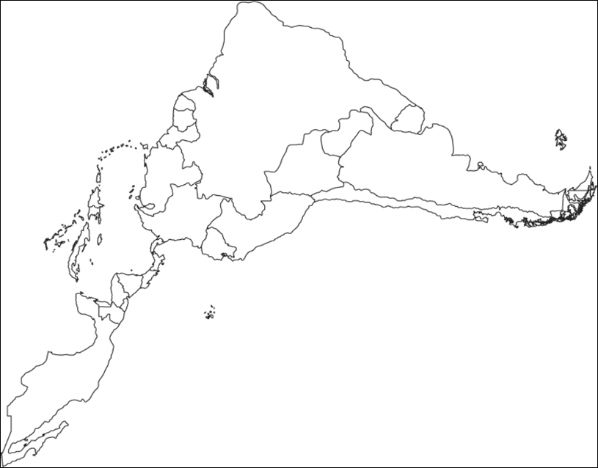

Oil Pollution in Venezuela

**The issue is…**

* **Venezuela is one of the largest producers of oil and natural gas in the world**
* **The country is the fifth-largest producer of oil in the world**
* **It has been producing oil for about a hundred years**
* **It is now one of the top four sources of oil for the United States**
* **In fact, about 15 percent of the oil sold in the United States comes from Venezuela**
* **The money from oil sales accounts for about half the money received by the government of Venezuela**

**The consequences of this oil-pollution in Venezuela are…**

* **Oil spills and tanker leaks have damaged the environment in the region.**
* **Lake Maracaibo is the largest lake in South America.** 
  + **Due to the large amount of oil removed from the nearby areas, the land in the area is changing.**
  + **The eastern shore of the lake is dropping about three inches a year**
  + **The government built a dike to keep the water in the lake from flooding the nearby homes, towns, and farms**

**The impact on surrounding areas is…**

* **Along the Caribbean Sea, Venezuela’s coast has become polluted with oil**
* **They have also hurt the ability of fishermen to earn a living**
* **The country leads South America in the production of the gas carbon dioxide, which is a by-product of burning fossil fuels like natural gas and oil**
* **High levels of carbon dioxide in the air can cause breathing problems for children and the elderly**
* **Other health problems can occur in healthy adults after long exposure to high levels of carbon dioxide**
  + - **Some scientists believe that increases in carbon dioxide contribute to “global warming”**
    - **They believe this because carbon dioxide tends to trap warm air at the surface of the Earth instead of letting it rise**

Deforestation of

Amazon Rain Forest

**Describe factors causing destruction of the rain forest…**

* **Cutting of trees or logging**
* **Mining**
* **Cattle ranching – largest form of deforestation**
* **Farming**

**Explain the concerns regarding the destruction of the rain forest in Brazil…**

* **Environmental campaignists feel there will be no Amazon Rain Forest in 40 years**
* **Causes of deforestation are still in place – which creates less forest to produce goods that humans need**
* **Global warming could lead to melting ice sheets, rising sea levels, and worldwide flooding**
* **The forest holds large amounts of water – remove the trees and the water will have to go somewhere; the Basin will be come drier and land surfaces hotter, stronger storms, no canopy to intercept rain; all of this leads to soil erosion**
* **Estimates say 20% of world’s oxygen is produced in the Amazon region**

**Describe the consequences associated with this destruction…**

* **Mining has left an ugly scar on the landscape**
* **Parts of forests being destroyed to the point of no repair**
* **Climate and Greenhouse effect (energy/heat being trapped by carbon dioxide in atmosphere)**
* **Trees help maintain balance of gases in the atmosphere – rainforest is the main storehouse of carbon, cut the trees down, they release the carbon, forming carbon dioxide when it hits the air**

.